Florian Fox
Singer – Performer – Songwriter
Prix Walo Winner
Texas Sounds Int. Country Music Award Winner / Recipient of U.S. Certificate of Congressional Recognition
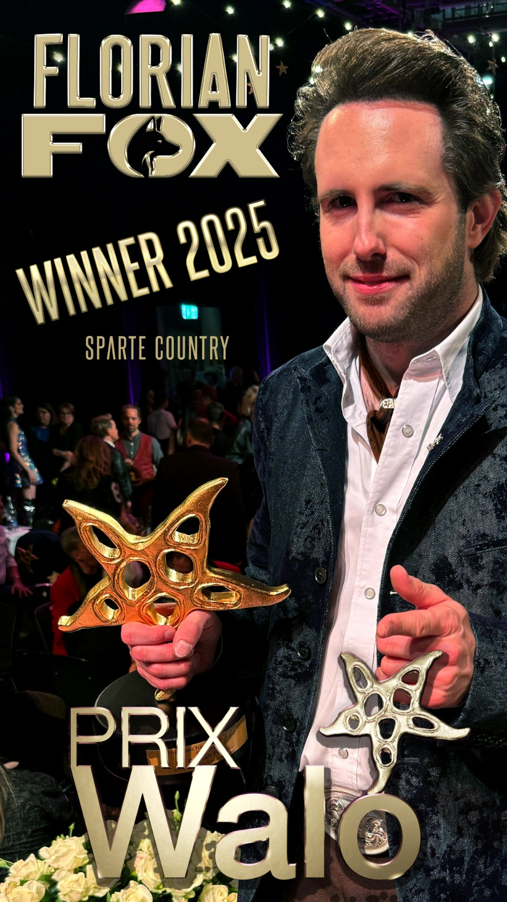
Photo by Albi Matter at Show & Music AG
Florian Fox is the "Swiss guy of the hour". With his neo-traditional country style, Florian Fox (33) has played his way onto some of the most renowned festival and club stages and into the heart of the US music metropolis of Nashville in less than four years. His new country-pop EP "True Love", released on February 14, 2025, accompanies him on his “True Love Tour” alongside U.S. singer Drake Milligan and other renowned artists. On May 24, 2025, he was given the most important award in the Swiss show industry, the Prix Walo, in the category Country, live on Swiss national television.
In the middle of the pandemic, Florian ventured to the music metropolis of Nashville, where he recorded his first solo album "Made in U.S.A" with U.S. star Chuck Mead (BR5-49, Musicians' Hall of Fame) and shortly afterwards recorded an EP with original members of Johnny Cash’s band. Since then, his career has taken a steep rise: In 2024, he released his first live album on Swiss national television, became a voting member of the US Country Music Association (CMA), nominee of the foremost Swiss culture award “Prix Walo” and won a Texas Sounds Int. Country Music Award for "Entertainer of the Year" as well as a certificate of recognition from U.S. Congress. In October, after an extensive tour through the States, he performed at the legendary CMA Theater of the Country Music Hall of Fame in Nashville. Florian now regularly performs on the main stages of major country music festivals and high-class venues. He has developed a stunning presence on the air and in the media (see select press on www.florianfox.com/press ).
On May 24, 2025, Florian was given the most important award in the Swiss show industry at the Prix Walo gala in Zurich. He impressed the jury in the Country category and received the Prix Walo 2025 for his outstanding musical achievements on both sides of the Atlantic.
On his new EP "True Love" released on February 14, 2025, Florian skillfully combines a powerful Nashville sound with delicate roots music elements such as banjo and dobro. The songs tell the original story of the young, but already tested, matured and well-traveled singer: In the single "Home" (pre-released on January 24), Florian has found his center both musically and personally and conveys the message with a stomping, very catchy tune. "Country Man" is a loving ode to his ageing father, who awakened in him his love of country music. In the funky "Toxic Fascination", Florian remembers a fiery lover who almost threw him off his life’s track. With the ballad "True Love", which he co-wrote with U.S. artist Drake Milligan, he makes even the most sedate of souls pine with him for one true love with a voice reminiscent of Roy Orbison. "Daphne and Till" is a modern country fairytale that proves that great love can be found even in the age of dating apps. With the honky-tonk smasher "Friday Night", Florian rounds off the EP in the spirit of an exuberant night in the music capital of Nashville, Tennessee.
Website: www.florianfox.com | Instagram: florianfox.music | Facebook: florianfox.music | Booking and Management: Show & Music AG, Int. Artist Agency, P.O. Box, 8047 Zurichmatter@showandmusic.ch +41 (0) 44 461 00 66
Broad media presence (selection): www.florianfox.com/press
Switzerland: Blick, SRF Gesichter & Geschichten, Schweizer Illustrierte, Schweizer Familie, Tages-Anzeiger, Zürcher Tagblatt, Basler Zeitung, Berner Zeitung, Der Bund, Thuner Tagblatt, Zürichsee Zeitung, Radio SRF 1, Radio Zürisee, SRF Swissinfo, CountryStyle, Thurgauer Zeitung, St. Galler Tagblatt.
USA: WAFB Channel 9, Eagle 98.1 The Rock Station, Radio 107.1 The River, Radio 90.7 FM WWOZ (New Orleans, LA).
Nashville/Zurich, May 2025

 | Booking & Management | 2025 Winner “Country”
 |  | 

