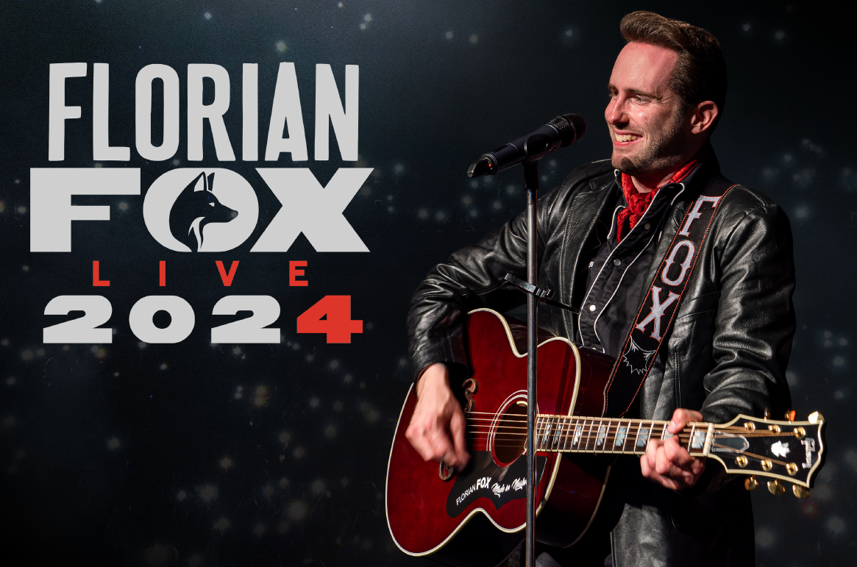
Florian Fox
Vocalist – Performer – Songwriter from Switzerland (Europe)
Texas Sounds Int. Country Music Award Winner / Prix Walo Newcomer
Voting CMA Member since 2024
Extended bio:
Already at the age of 15, Swiss country singer-songwriter Florian Fox formed what was then Switzerland's youngest country-rockabilly band, "The Black Barons". With the band he won a Swiss newcomer award and the band's album was called one of the best Swiss albums of 2013 by Swiss national radio. He has opened for acts such as The Bellamy Brothers, Lorrie Morgan, Johnny Reid and many more.
In 2020, in the midst of the pandemic, Florian Fox moved to the country music capital of Nashville to take his musical career to the next level. In October 2020, he won the award for "Outstanding Live Production" at the Texas Sounds International Country Music Awards in Jefferson, TX. In Nashville, his first solo album "Made in U. S. A" was produced by U.S. country music star Chuck Mead (BR5-49, Musicians' Hall of Fame). The album was released on May 13, 2022, both as a vinyl LP and on all digital platforms.
Florian Fox is setting out for the great leap: The single release, 'Swiss Guy', published in early 2022 was a full-scale success, with its accompanying music video, in which Fox humorously re-enacts experiences of his early days as a Swiss guy in Nashville, achieving over 30,000 views within days. In February, he appeared on the U.S. Outlaw Country Music Cruise alongside Chuck Mead. The line-up of the Outlaw Cruise included legends such as Rodney Crowell, Emmylou Harris, Carlene Carter and Mead himself. In June 2022, he played a U.S. tour of Louisiana and Tennessee, which included in particular the world-famous Nashville honky tonks 'Robert's Western World' and 'American Legion Post 82'. The following tour through Switzerland regularly brought about sold-out venues and concert halls.
2023 saw the release of Florian Fox's EP "Made in Nashville". The EP which was dedicated to roots music featured former Johnny Cash bassist Dave Roe, Country Music Hall of Fame member Charlie McCoy and Grand Ole Opry music director Kerry Marx. The 2023 tour of the U.S. states of Alabama, Louisiana and Switzerland regularly brought Florian Fox sold-out auditoriums and included some of the most prestigious country music festivals on both sides of the Atlantic. In particular, Florian Fox thrilled audiences on the main stage of Country Night Gstaad together with US superstar Miranda Lambert and other top acts. He was also headliner of the 1st Country Music on the River cruise on the Danube.
On February 24, 2024 Florian Fox's first live album "Live At Country Night Gstaad" was published. The release took place during a special night at the Int. Country Music Festival Albisgütli in Zurich and was televised by national television (SRF1). He headlined the world-renowned Trucker & Country Festival in Interlaken in June. His 2024 U.S. tour includes iconic venues such as Gruene Hall in New Braunfels, TX and takes him all the way to the CMA Theater at the Country Music Hall of Fame in Nashville, TN.
Florian Fox is a member of the Country Music Association (CMA) and the Americana Music Association. He is the ambassador of the International Country Music Hall of Fame of Switzerland. Since 2022, the largest Swiss media house, Ringier, has been his official media partner.

Website: www.florianfox.com | Instagram: florianfox.music | Facebook: florianfox.music
Contact: Show & Music AG, Int. Artist Agency, P.O. Box, 8047 Zurich, Switzerland. Phone: +41 (0)44 461 00 66. E-Mail: matter@showandmusic.ch
Selected Press: www.florianfox.com/press
Nashville/Zurich, June 2024
 | Booking & Management | Official Media Partner
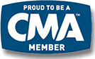 |  | 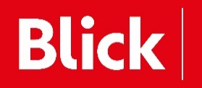
Newcomer bei


